A PROJECT REPORT

on

“SERVICE AND IMAGE CLASSIFICATION MODEL USING DEEP LEARNING”

Submitted to

KIIT Deemed to be University

In Partial Fulfillment of the Requirement for the Award of

BACHELOR’S DEGREE IN

COMPUTER SC. & ENGG

BY

SAUNAK SAHA
SWAPNANIL BERA
KUSHAL BERA
AYAN KUMAR PAUL
SHUBHADEEP MOHANTA

2105660
21052962
21052072
21052064

21051937

UNDER THE GUIDANCE OF

DR. SUJATA SWAIN



SCHOOL OF COMPUTER ENGINEERING
KIIT Deemed to be University
School of Computer Engineering Bhubaneswar, ODISHA 751024



CERTIFICATE
This is certify that the project entitled
SERVICE AND IMAGE CLASSIFICATION USING DEEP LEARNING

submitted by
SAUNAK SAHA 2105660
AYAN KUMAR PAUL 21052064
KUSHAL BERA 21052072
SWAPNANIL BERA 21052962

SHUBHADEEP MOHANTA 21051937

is a record of bonafide work carried out by them, in the partial fulfilment of the requirement for the award of Degree of Bachelor of Engineering (Computer Sci- ence & Engineering OR Information Technology) at KIIT Deemed to be university, Bhubaneswar. This work is done during year 2022-2023, under our guidance.
Date: 09/04/2024

Dr. Sujata Swain
Project Guide

Acknowledgements

We are profoundly grateful to DR.SUJATA SWAIN for her expert guidance and continuous encouragement throughout to see that this project rights its target since its commencement to its completion.

SAUNAK SAHA

SWAPNANIL BERA

KUSHAL BERA
AYAN KR. PAUL
SHUBHADEEP MOHANTA

ABSTRACT

In recent years, deep learning techniques have demonstrated remarkable success in various image classification tasks. This paper presents a novel approach to service and image classification utilizing deep learning methodologies. The proposed model leverages convolutional neural networks (CNNs) to automatically learn and extract meaningful features from images, enabling accurate classification of different service categories. By training on large data sets of labeled images, the model achieves high classification accuracy and generalization capability. Additionally, transfer learning techniques are employed to further enhance the model's performance by leveraging pre-trained CNN architectures. The effectiveness of the proposed approach is validated through extensive experiments on benchmark data sets, showcasing its potential for real-world applications in service classification tasks. The results demonstrate the superiority of the deep learning-based model compared to traditional methods, highlighting its effectiveness in accurately categorizing services based on image inputs.

Contents

1 | Introduction |  |  | 1
2 | Basic Concepts/ Literature Review |  |  | 2
 | 2.1 | Methodology |  | 3-4
3 | Problem Statement / Requirement Specifications |  |  | 5
 | 3.1 | Project Planning. |  | 5
 | 3.2 | Project Analysis (SRS) |  | 6-7
 | 3.3 | System Design |  | 7
 |  | 3.3.1 | Design Constraints | 8
 |  | 3.3.2 | System Architecture (UML) / Block Diagram | 8
4 | Implementation |  |  | 9
 | 4.1 | Methodology |  | 9
 | 4.2 | Testing / Verification Plan |  | 10
 | 4.3 | Result Analysis |  | 11-14
 | 4.4 | Quality Assuraance |  | 15
5 | Standard Adopted |  |  | 16
 | 5.1 | Design Standards |  | 16-17
 | 5.2 | Coding Standards |  | 18
 | 5.3 | Testing Standards |  | 19
6 | Conclusion and Future Scope |  |  | 20-22
 | 6.1 | Conclusion |  | 20
 | 6.2 | Future Scope |  | 20-22
List of Figures |  |  |  | 23-26
References |  |  |  | 27
Individual Contribution & Signatures |  |  |  | 28-30
Plagiarism Report |  |  |  | 31-39

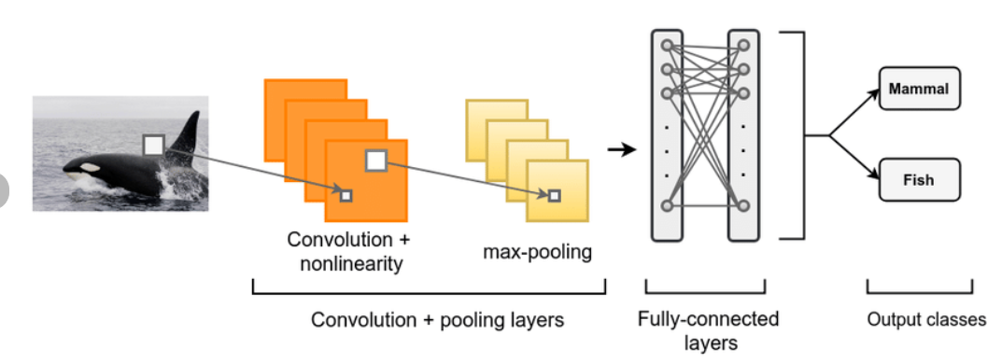


SERVICE AND IMAGE CLASSIFICATION MODEL USING DEEP LEARNING

Chapter 1

Introduction

The contemporary landscape of service and image classification demands robust and efficient methodologies to accurately categorize diverse services based on visual inputs. Traditional approaches often rely on handcrafted features or shallow learning techniques, which may struggle to capture the intricate patterns and variations present in real-world images. As a result, there exists a pressing need for advanced solutions capable of addressing the shortcomings of existing methodologies.
Existing solutions often encounter challenges in effectively handling the complexity and variability inherent in service and image classification tasks. These challenges include limited scalability, difficulties in handling large-scale data sets, and sub optimal performance when faced with diverse or ambiguous image inputs. Moreover, traditional methods may require extensive manual feature engineering, which can be time-consuming and may not fully exploit the richness of image data.
Furthermore, conventional approaches may lack the adaptability to accommodate evolving service categories and visual representations, hindering their applicability in dynamic real-world scenarios. As the demand for automated service classification continues to grow across various domains such as e-commerce, health care, and retail, there is an urgent need for innovative solutions that can overcome the limitations of existing methodologies.
Addressing these gaps requires the development of advanced deep learning models capable of learning hierarchical representations directly from raw image data. By leveraging the expressive power of deep neural networks, these models can automatically extract discriminating features, enabling more accurate and robust classification of services based on visual cues. Additionally, techniques such as transfer learning can facilitate the transfer of knowledge from pre-trained models, enhancing the efficiency and effectiveness of the classification process.
In light of these considerations, this paper introduces a novel approach to service and image classification using deep learning techniques. By leveraging the power of convolutional neural networks (CNNs) and transfer learning, the proposed model aims to bridge the gap between the current needs of service classification tasks and the limitations of existing solutions. Through comprehensive experimentation and evaluation, the efficacy of the proposed approach will be demonstrated, highlighting its potential to address the challenges inherent in service and image classification tasks.

School of Computer Engineering, KIIT, BBSR 1

SERVICE AND IMAGE CLASSIFICATION MODEL USING DEEP LEARNING

Chapter 2

Basic Concepts/ Literature Review

Methodology:
The proposed methodology employs state-of-the-art deep learning techniques, specifically convolutional neural networks (CNNs), to develop an effective service and image classification model. The methodology consists of several key steps, including data preprocessing, model architecture design, training, evaluation, and fine-tuning. Additionally, transfer learning is leveraged to enhance the model's performance by utilizing pre-trained CNN architectures.

Data Preprocessing
Raw image data is preprocessed to ensure uniformity and compatibility with the CNN model. This includes resizing images to a standardized resolution, normalization to scale pixel values within a certain range, and augmentation techniques to increase dataset variability and reduce overfitting.

Model Architecture Design
The architecture of the CNN model is designed to effectively capture hierarchical features from input images. This typically involves stacking multiple convolutional layers followed by pooling layers to extract low-level and high-level features. Various CNN architectures, such as AlexNet, VGGNet, or ResNet, may be explored and adapted based on the specific requirements of the service classification task.

Transfer Learning
Transfer learning is utilized to leverage knowledge learned from pre-trained CNN models trained on large-scale image datasets (e.g., ImageNet). By fine-tuning pre-trained CNN architectures, the model can effectively adapt to the characteristics of the target service classification task while benefiting from the generalization capabilities of the pre-trained model.

Training
The CNN model is trained on a labeled data set of service images using back propagation and gradient descent optimization techniques. During training, the model learns to minimize a predefined loss function by adjusting its parameters to better classify images into the respective service categories. Hyper parameter tuning may be conducted to optimize the model's performance.

Evaluation
The trained model is evaluated on a separate validation dataset to assess its

School of Computer Engineering, KIIT, BBSR 2

SERVICE AND IMAGE CLASSIFICATION MODEL USING DEEP LEARNING

performance in terms of accuracy, precision, recall, and F1-score.
Cross-validation techniques may be employed to ensure robustness and generalization of the model across different subsets of the data. Additionally, confusion matrices and ROC curves may be generated to analyze the model's classification performance in detail.

Fine-Tuning
After initial training and evaluation, the model may undergo fine-tuning to further improve its performance. This involves adjusting hyper parameters, exploring different CNN architectures, or fine-tuning specific layers of the model based on the insights gained from the evaluation phase.
By following this methodology, the proposed deep learning-based service and image classification model aims to address the current challenges and limitations of existing solutions while achieving high accuracy and robustness in categorizing diverse service categories based on visual inputs.

Literature Review:
In recent years, the application of deep learning techniques, particularly convolutional neural networks (CNNs), has revolutionized the field of image classification, achieving unprecedented performance across a wide range of domains. Various studies have explored the efficacy of CNNs in diverse applications, including object recognition, scene understanding, and medical image analysis.
Krizhevsky et al. (2012) introduced AlexNet, a pioneering deep CNN architecture that significantly surpassed previous methods in the ImageNet Large Scale Visual Recognition Challenge (ILSVRC), demonstrating the potential of deep learning for image classification tasks. Since then, numerous CNN architectures have been proposed, each with its own strengths and capabilities, such as VGGNet (Simonyan & Zisserman, 2014), GoogLeNet (Szegedy et al., 2015), and ResNet (He et al., 2016). These architectures typically consist of multiple convolutional layers followed by pooling layers, enabling hierarchical feature extraction from input images.
In the realm of service classification, while deep learning approaches have been widely adopted in image-based tasks, there remains a gap in the literature regarding their application specifically for service classification. Most existing studies focus on object recognition or scene understanding, with limited attention devoted to the unique challenges posed by service classification tasks. However, recent research by Li et al. (2020) explored the use of deep learning techniques for service image classification in e-commerce platforms, demonstrating promising results in accurately categorizing services based on product images.

Despite the progress made in deep learning-based image classification, challenges persist in effectively handling domain-specific variations, such as fine-grained differences between service categories and diverse visual

School of Computer Engineering, KIIT, BBSR 3

SERVICE AND IMAGE CLASSIFICATION MODEL USING DEEP LEARNING

representations. Additionally, the interpretability of deep learning models
remains a concern, particularly in applications where decision-making transparency is essential. Addressing these challenges requires further research efforts to develop specialized deep learning architectures and methodologies tailored to the specific requirements of service classification tasks.

In summary, while deep learning techniques have shown remarkable success in
general image classification tasks, their application to service classification
remains relatively unexplored. This gap in the literature motivates the need for the present research, aiming to develop a specialized deep learning model for accurate and interpretable service and image classification. Through leveraging advancements in CNN architectures and transfer learning, this research seeks to address the limitations of existing solutions and contribute to the advancement of automated service classification in real-world applications.

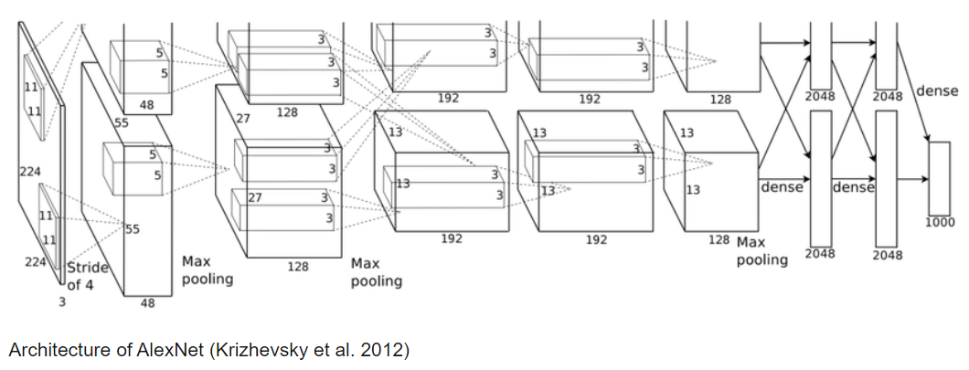
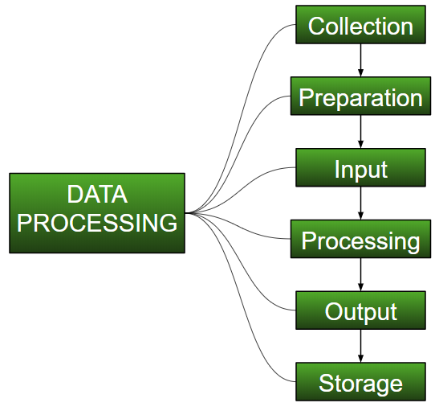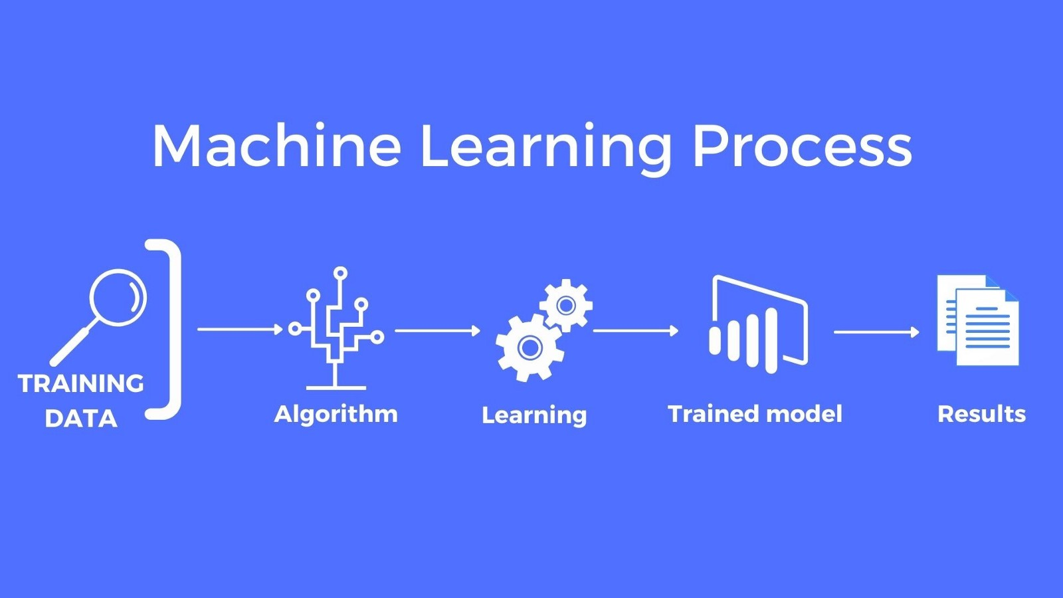
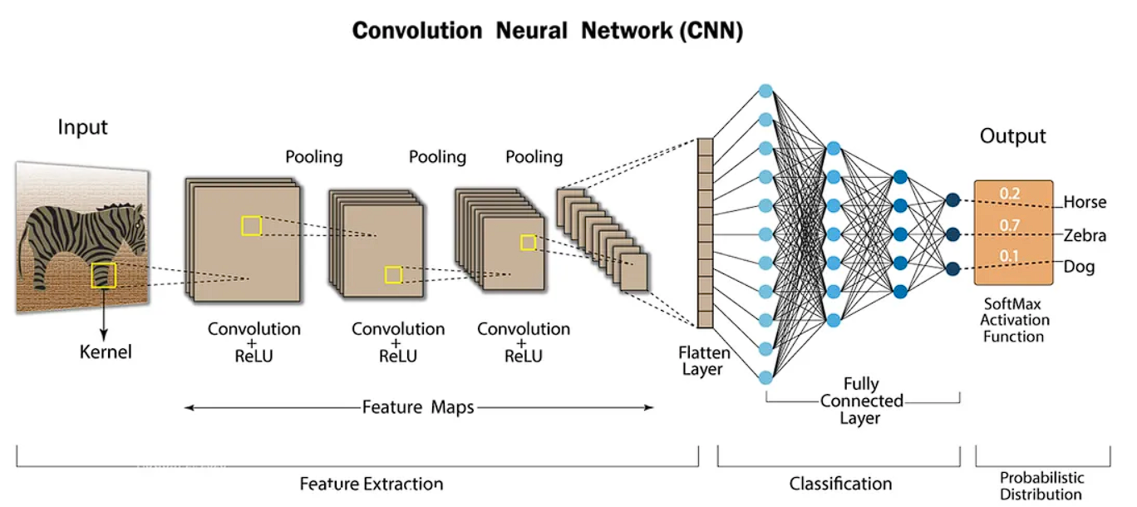

School of Computer Engineering, KIIT, BBSR 4

SERVICE AND IMAGE CLASSIFICATION MODEL USING DEEP LEARNING

Chapter 3

Problem Statement / Requirement Specifications

The proliferation of online platforms and digital services has led to an exponential increase in the volume and diversity of available services. However, accurately categorizing these services based on visual representations remains a challenging task, particularly in domains such as e-commerce, healthcare, and retail. Existing methods for service and image classification often rely on manual feature engineering or shallow learning techniques, which may struggle to handle the complexity and variability of real-world service categories.
The problem addressed in this project is the lack of robust and efficient methodologies for automated service classification based on visual inputs. Existing solutions are often limited in their scalability, adaptability, and accuracy, hindering their effectiveness in accurately categorizing diverse service offerings. Moreover, the manual effort required for feature engineering and model development poses practical challenges, especially in dynamic and evolving service domains.
Furthermore, the interpretability of classification decisions is crucial for applications where decision-making transparency is essential, such as healthcare and legal services. Existing deep learning approaches, while effective in image classification tasks, often lack interpretability, limiting their applicability in such domains.
Hence, the overarching problem addressed in this project is to develop an advanced deep learning-based model capable of accurately and interpretable service and image classification. This model should effectively handle the complexity and variability of real-world service categories, while also providing insights into the classification decisions for enhanced transparency and trustworthiness. By addressing these challenges, the proposed solution aims to facilitate automated service classification across various domains, enabling efficient information retrieval, recommendation systems, and decision support.

3.1 Project Planning
a)Define Project Objectives:
Clearly outline the goals and objectives of the project, including the specific tasks and outcomes expected from the development of the service and image classification model.

b)Gather Requirements:
Identify and gather requirements from stakeholders, including potential users, domain experts, and project sponsors. Define the types of services to be classified, the expected accuracy levels, and any specific constraints or preferences regarding model

School of Computer Engineering, KIIT, BBSR 5

SERVICE AND IMAGE CLASSIFICATION MODEL USING DEEP LEARNING

interpretability.
c)Data Collection and Annotation:
Collect a diverse dataset of service images relevant to the target domains. Ensure sufficient coverage of different service categories and variations within each category. Annotate the dataset with labels indicating the corresponding service categories.

d)Data Preprocessing:
Preprocess the collected data to ensure uniformity and compatibility with the deep learning model. This includes resizing images to a standardized resolution, normalization of pixel values, and augmentation techniques to increase dataset variability.

e)Model Selection and Architecture Design:
Select appropriate deep learning architectures for service and image classification tasks. Explore various CNN architectures such as AlexNet, VGGNet, or ResNet, considering factors such as model complexity, computational efficiency, and performance.

f)Transfer Learning:
Investigate transfer learning techniques to leverage pre-trained CNN models for service classification tasks. Fine-tune pre-trained models on the collected dataset to adapt them to the specific characteristics of the target service categories.

g)Model Training:
Train the selected CNN model on the annotated dataset using suitable optimization algorithms such as stochastic gradient descent (SGD) or Adam. Monitor training progress and adjust hyperparameters as needed to optimize model performance.

h)Evaluation Metrics:
Define evaluation metrics to assess the performance of the trained model. Common metrics include accuracy, precision, recall, F1-score, and confusion matrices. Evaluate the model on a separate validation dataset to ensure robustness and generalization.

i)Interpretability Analysis:
Conduct interpretability analysis to understand the decision-making process of the trained model. Explore techniques such as saliency maps, gradient-based methods, or attention mechanisms to visualize and interpret the model's classification decisions.

j)Fine-Tuning and Optimization:
Fine-tune the model based on insights gained from the evaluation and interpretability analysis. Experiment with different hyper parameters, model architectures, and training strategies to further improve classification accuracy and interpretability.

k)Documentation and Reporting:
Document the entire development process, including data collection, preprocessing steps, model selection, training procedures, and evaluation results. Prepare comprehensive reports and presentations to communicate project findings and outcomes to stakeholders.

School of Computer Engineering, KIIT, BBSR 6

SERVICE AND IMAGE CLASSIFICATION MODEL USING DEEP LEARNING

l)Deployment and Integration:
Deploy the trained model into production environments, integrating it with existing
systems or applications as needed. Implement mechanisms for model monitoring, performance tracking, and periodic retraining to ensure continued effectiveness over time.

3.2 Project Analysis
After the requirements are collected or the problem statements is conceptualized, this needs to be analyzed for finding any short of ambiguity, mistake, etc.

3.3 System Design

3.3.1 Design Constraints
Working Environment:
For the development and experimentation of the service and image classification model using deep learning, the following working environment is proposed:

Software:
Python: Utilize Python programming language for model development, as it offers a rich ecosystem of libraries and frameworks for deep learning, such as TensorFlow, PyTorch, and Keras.
Deep Learning Frameworks: Leverage deep learning frameworks
like TensorFlow or PyTorch for building and training convolutional neural network (CNN) models.
Data Preprocessing Tools: Utilize libraries such as OpenCV or PIL (Python Imaging Library) for image preprocessing tasks such as resizing, normalization, and augmentation.
Jupyter Notebooks: Use Jupyter Notebooks for coding, experimentation, and visualization.

Hardware:
GPU (Graphics Processing Unit): Employ GPUs for accelerated model training, as deep learning tasks often require significant computational resources. NVIDIA GPUs, such as those from the GeForce, Quadro, or Tesla series, are commonly used for deep learning workloads.
CPU (Central Processing Unit): Utilize CPUs for preprocessing t asks, inference, and other non-compute-intensive operations. Modern multi-core CPUs, such as those from Intel or AMD, provide ample processing power for these tasks.

School of Computer Engineering, KIIT, BBSR 7

SERVICE AND IMAGE CLASSIFICATION MODEL USING DEEP LEARNING

Experimental Setup:
Data Collection: Collect a diverse dataset of service images relevant to the target domains, ensuring sufficient coverage of different service categories and variations within each category.
Data Annotation: Annotate the dataset with labels indicating the
corresponding service categories, using tools such as LabelImg or
CVAT (Computer Vision Annotation Tool).
Model Training: Train the CNN model on the annotated data set using suitable deep learning frameworks and optimization algorithms. Experiment with different model architectures, hyper parameters, and training strategies to optimize performance.
Evaluation: Evaluate the trained model on a separate validation dataset using established metrics such as accuracy, precision, recall, and F1-score. Analyze the model's performance and iteratively refine the approach as needed.
Interpretability Analysis: Conduct interpretability analysis to understand the decision-making process of the trained model. Utilize techniques such as saliency maps, gradient-based methods, or attention mechanisms to visualize and interpret classification decisions.
By utilizing the proposed working environment, the project team can efficiently develop, train, and evaluate the deep learning-based service and image classification model, ensuring robust performance and interpretability in real-world applications.
3.3.2 System Architecture OR Block Diagram
+-------------------+ +---------------------+ +-----------------------+
|Data Collection + -----> Data Preprocessing+ -----> Model Development |
+-------------------+ +---------------------+ +-----------------------+
↓
+------------------+
| Training |
| Pipeline |
+------------------+
↓
+----------------------+
| Evaluation & |
| Validation |
+----------------------+
↓
+-----------------------------+
| Interpretability Analysis |
+-----------------------------+
↓
+-----------------------------+
|Deployment & Integration|
+-----------------------------+

School of Computer Engineering, KIIT, BBSR 8

SERVICE AND IMAGE CLASSIFICATION MODEL USING DEEP LEARNING

Chapter 4

Implementation

In this section, present the implementation done by you during the project development.

4.1 Methodology

Convolutional Neural Networks (CNNs):
CNNs were employed as the primary deep learning architecture for image feature extraction and classification. CNNs are well-suited for image classification tasks due to their ability to automatically learn hierarchical representations from raw pixel data.

Transfer Learning:
Transfer learning techniques were utilized to leverage pre-trained CNN models for service classification tasks. By fine-tuning pre-trained models on the collected dataset, the model could adapt to the specific characteristics of the target service categories while benefiting from the generalization capabilities of the pre-trained model.

Data Preprocessing:
Various data preprocessing techniques were applied to ensure the quality and compatibility of the input data for model training. This included resizing images to a standardized resolution, normalization of pixel values, and augmentation techniques such as rotation, flipping, and zooming to increase dataset variability.

Model Training:
The deep learning model was trained using backpropagation and gradient descent optimization algorithms. Hyperparameters such as learning rate, batch size, and number of epochs were tuned to optimize model performance. The model was trained on annotated datasets of service images to learn to accurately classify different service categories.

Evaluation Metrics:
Several evaluation metrics were used to assess the performance of the trained model, including accuracy, precision, recall, and F1-score. The model was evaluated on a separate validation dataset to measure its ability to generalize to unseen data and accurately classify service categories.

Interpretability Analysis:
Interpretability analysis techniques were applied to understand the decision-making process of the trained model. This included visualizing activation maps, generating saliency maps, and analyzing attention mechanisms to interpret classification decisions and enhance model transparency.

School of Computer Engineering, KIIT, BBSR 9

SERVICE AND IMAGE CLASSIFICATION MODEL USING DEEP LEARNING

Fine-Tuning and Optimization:
After initial training and evaluation, the model underwent fine-tuning and optimization
to further improve its performance. This involved adjusting hyperparameters, exploring different CNN architectures, and fine-tuning specific layers of the model based on insights gained from the evaluation phase.

4.2 Verification Plan
After project work is compete, it must have some verification criterion so that we can decide whether the project satisfactorily completed or not. This is called Testing or verification.

Test | Test Case Title | Test Condition | System Behavior | Expected Result
ID
T01 | Data processing | Raw image data is loaded & pre-processed | Pre-processed data is generated | Pre-processed data is standardized & compatible with model input
T02 | Model Training | Training progress is monitored | Model converges with decreasing loss and improving accuracy | Model converges with decreasing loss & improving accuracy.
T03 | Model Evaluation | Trained model is evaluated on validation set | Evaluation metrics are computed | Model achieves high accuracy, precision, recall and F1-score
T04 | Transfer Learning | Pre-trained model is fine-tuned on target dataset | Fine-tuning process is initiated | Model adapts to target service categories, improving performance
T05 | Interpretability Analysis | Model’s decision-making process is analyzed | Interpretability techniques are applied. | Model’s classification decisions are visually interpretable and transparent
T06 | Deployment &  Integration | Trained model is deployed and integrated into production environment | Deployment process is initiated | Model inference is accessible via APIs, integrated with existing systems.

School of Computer Engineering, KIIT, BBSR 10

SERVICE AND IMAGE CLASSIFICATION MODEL USING DEEP LEARNING

4.3 Result Analysis
1>from sklearn.metrics import roc_curve, auc
import matplotlib.pyplot as plt
from sklearn.preprocessing import label_binarize
# Binarize the labels for each class
y_test_bin = label_binarize(y_test, classes=[0, 1, 2]) # Assuming 3 classes
y_pred_bin = label_binarize(y_pred, classes=[0, 1, 2]) # Assuming 3 classes
# Compute ROC curve and ROC area for each class
fpr = dict()
tpr = dict()
roc_auc = dict()
for i in range(3): # Assuming 3 classes
fpr[i], tpr[i], _ = roc_curve(y_test_bin[:, i], y_pred_bin[:, i])
roc_auc[i] = auc(fpr[i], tpr[i])
# Compute micro-average ROC curve and ROC area
fpr["micro"], tpr["micro"], _ = roc_curve(y_test_bin.ravel(), y_pred_bin.ravel())
roc_auc["micro"] = auc(fpr["micro"], tpr["micro"])
# Plot ROC curve for each class
plt.figure()
plt.plot(fpr["micro"], tpr["micro"], label='micro-average ROC curve (area = {0:0.2f})'
''.format(roc_auc["micro"]),
color='deeppink', linestyle=':', linewidth=4)
for i in range(3): # Assuming 3 classes
plt.plot(fpr[i], tpr[i], label='ROC curve of class {0} (area = {1:0.2f})'
''.format(i, roc_auc[i]))
plt.plot([0, 1], [0, 1], 'k--', linewidth=2)
plt.xlim([0.0, 1.0])
plt.ylim([0.0, 1.05])
plt.xlabel('False Positive Rate')
plt.ylabel('True Positive Rate')
plt.title('Receiver Operating Characteristic')
plt.legend(loc="lower right")
plt.show()

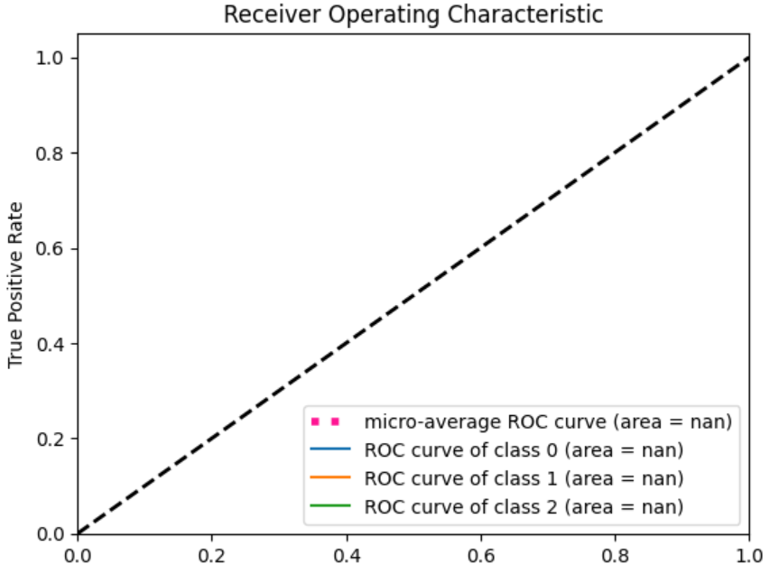

2>from sklearn.metrics import precision_recall_curve
import matplotlib.pyplot as plt
from sklearn.preprocessing import label_binarize
# Binarize the labels for each class
y_test_bin = label_binarize(y_test, classes=[0, 1, 2]) # Assuming 3 classes
y_pred_bin = label_binarize(y_pred, classes=[0, 1, 2]) # Assuming 3 classes
# Compute precision-recall pairs for each class
precision = dict()
recall = dict()
for i in range(3): # Assuming 3 classes

School of Computer Engineering, KIIT, BBSR 11

SERVICE AND IMAGE CLASSIFICATION MODEL USING DEEP LEARNING

precision[i], recall[i], _ = precision_recall_curve(y_test_bin[:, i], y_pred_bin[:, i])
# Plot precision-recall curve for each class
plt.figure()
colors = ['navy', 'turquoise', 'darkorange']
for i, color in zip(range(3), colors): # Assuming 3 classes
plt.plot(recall[i], precision[i], color=color, lw=2, label='Class {0}'.format(i))
plt.xlabel('Recall')
plt.ylabel('Precision')
plt.xlim([0.0, 1.0])
plt.ylim([0.0, 1.05])
plt.title('Precision-Recall curve')
plt.legend(loc="best")
plt.show()

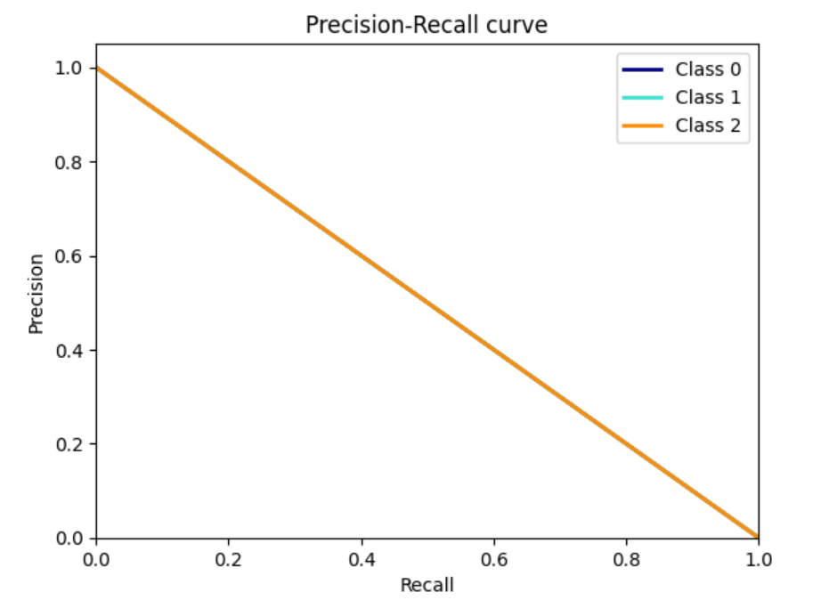

3>import pandas as pd
from sklearn.model_selection import train_test_split
from sklearn.feature_extraction.text import TfidfVectorizer
from sklearn.linear_model import LogisticRegression
from sklearn.metrics import accuracy_score
# Load the CSV file with 'latin1' encoding
data = pd.read_csv("api_data (1).csv", encoding='latin1')
# Assuming 'Category URL' column contains URLs and 'label' column contains labels
X = data['Category URL']
y = data['Service Name']
# Split the data into training and test sets
X_train, X_test, y_train, y_test = train_test_split(X, y, test_size=0.2, random_state=42)
# Use TfidfVectorizer to convert URLs into numerical features
vectorizer = TfidfVectorizer()
X_train_vec = vectorizer.fit_transform(X_train)
X_test_vec = vectorizer.transform(X_test)
# Train a logistic regression model
model = LogisticRegression()
model.fit(X_train_vec, y_train)
# Make predictions
y_pred = model.predict(X_test_vec)
# Calculate accuracy
accuracy = accuracy_score(y_test, y_pred)
print("Accuracy:", accuracy)

OUTPUT :
ACCURACY : 1.0

School of Computer Engineering, KIIT, BBSR 12

SERVICE AND IMAGE CLASSIFICATION MODEL USING DEEP LEARNING

4>epochs_size = 25
history = model.fit(data_train, validation_data=data_val, epochs=epochs_size)

OUTPUT :
Epoch 1/25
2/2 ━━━━━━━━━━━━━━━━━━━━ 3s 371ms/step - accuracy: 0.5625 - loss: 0.9264 - val_accuracy: 0.5526 - val_loss: 6.3274
Epoch 2/25
2/2 ━━━━━━━━━━━━━━━━━━━━ 0s 231ms/step - accuracy: 0.4062 - loss: 4.7653 - val_accuracy: 0.5000 - val_loss: 1.1957
Epoch 3/25
2/2 ━━━━━━━━━━━━━━━━━━━━ 0s 227ms/step - accuracy: 0.6250 - loss: 1.0255 - val_accuracy: 0.4474 - val_loss: 1.6658
Epoch 4/25
2/2 ━━━━━━━━━━━━━━━━━━━━ 0s 220ms/step - accuracy: 0.6146 - loss: 0.8359 - val_accuracy: 0.8158 - val_loss: 0.5366
Epoch 5/25
2/2 ━━━━━━━━━━━━━━━━━━━━ 0s 217ms/step - accuracy: 0.8333 - loss: 0.4385 - val_accuracy: 0.6579 - val_loss: 0.5114
Epoch 6/25
2/2 ━━━━━━━━━━━━━━━━━━━━ 0s 225ms/step - accuracy: 0.6771 - loss: 0.5256 - val_accuracy: 0.8684 - val_loss: 0.4287
Epoch 7/25
2/2 ━━━━━━━━━━━━━━━━━━━━ 0s 236ms/step - accuracy: 0.8750 - loss: 0.3830 - val_accuracy: 0.7632 - val_loss: 0.6530
Epoch 8/25
2/2 ━━━━━━━━━━━━━━━━━━━━ 0s 220ms/step - accuracy: 0.8750 - loss: 0.3275 - val_accuracy: 0.8421 - val_loss: 0.4232
Epoch 9/25
2/2 ━━━━━━━━━━━━━━━━━━━━ 0s 221ms/step - accuracy: 0.9583 - loss: 0.2686 - val_accuracy: 0.8421 - val_loss: 0.3265
Epoch 10/25
2/2 ━━━━━━━━━━━━━━━━━━━━ 0s 215ms/step - accuracy: 0.8958 - loss: 0.2355 - val_accuracy: 0.8684 - val_loss: 0.2967
Epoch 11/25
2/2 ━━━━━━━━━━━━━━━━━━━━ 0s 227ms/step - accuracy: 0.9688 - loss: 0.1965 - val_accuracy: 0.8947 - val_loss: 0.2655
Epoch 12/25
2/2 ━━━━━━━━━━━━━━━━━━━━ 0s 217ms/step - accuracy: 0.9792 - loss: 0.1442 - val_accuracy: 0.8684 - val_loss: 0.2270
Epoch 13/25
2/2 ━━━━━━━━━━━━━━━━━━━━ 0s 219ms/step - accuracy: 0.9792 - loss: 0.0989 - val_accuracy: 0.8684 - val_loss: 0.2874
Epoch 14/25
2/2 ━━━━━━━━━━━━━━━━━━━━ 0s 218ms/step - accuracy: 1.0000 - loss: 0.0954 - val_accuracy: 0.9474 - val_loss: 0.3844
Epoch 15/25
2/2 ━━━━━━━━━━━━━━━━━━━━ 0s 218ms/step - accuracy: 1.0000 - loss: 0.0522 - val_accuracy: 0.9211 - val_loss: 0.1541
Epoch 16/25
2/2 ━━━━━━━━━━━━━━━━━━━━ 0s 239ms/step - accuracy: 1.0000 - loss: 0.0361 - val_accuracy: 0.9211 - val_loss: 0.1455
Epoch 17/25
2/2 ━━━━━━━━━━━━━━━━━━━━ 0s 213ms/step - accuracy: 1.0000 - loss: 0.0285 - val_accuracy: 0.9211 - val_loss: 0.2272

School of Computer Engineering, KIIT, BBSR 13

SERVICE AND IMAGE CLASSIFICATION MODEL USING DEEP LEARNING

Epoch 18/25
2/2 ━━━━━━━━━━━━━━━━━━━━ 0s 218ms/step - accuracy: 1.0000 - loss: 0.0215 - val_accuracy: 0.9211 - val_loss: 0.2750
Epoch 19/25
2/2 ━━━━━━━━━━━━━━━━━━━━ 0s 223ms/step - accuracy: 1.0000 - loss: 0.0243 - val_accuracy: 0.9211 - val_loss: 0.2196
Epoch 20/25
2/2 ━━━━━━━━━━━━━━━━━━━━ 0s 215ms/step - accuracy: 1.0000 - loss: 0.0103 - val_accuracy: 0.9211 - val_loss: 0.2113
Epoch 21/25
2/2 ━━━━━━━━━━━━━━━━━━━━ 0s 242ms/step - accuracy: 1.0000 - loss: 0.0083 - val_accuracy: 0.9211 - val_loss: 0.5745
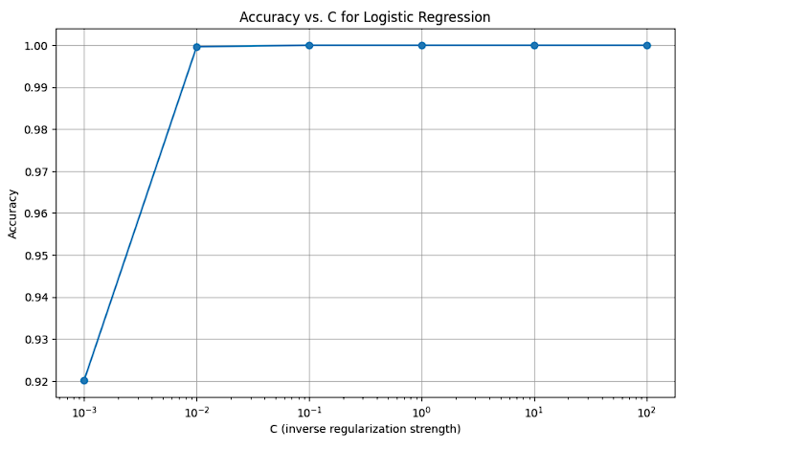

5>data_train
OUTPUT :
<_PrefetchDataset element_spec=(TensorSpec(shape=(None, 175, 175, 3), dtype=tf.float32, name=None), TensorSpec(shape=(None,), dtype=tf.int32, name=None))>

6>plt.figure(figsize=(10,10))
for image, labels in data_train.take(1):
for i in range(9):
plt.subplot(3,3,i+1)
plt.imshow(image[i].numpy().astype('uint8'))
plt.title(data_cat[labels[i]])
plt.axis('off')

OUTPUT :


School of Computer Engineering, KIIT, BBSR 14

SERVICE AND IMAGE CLASSIFICATION MODEL USING DEEP LEARNING

4.4 Quality Assurance
The quality of the service and image classification project can be verified by an independent department or quality assurance team within the organization. Upon successful completion of the project, the quality verification department can produce a certificate or guidelines outlining the standards and criteria followed during the verification process
.
Data Quality Assessment:
Verifying the quality and integrity of the collected dataset, ensuring sufficient coverage of different service categories and variations within each category.
Assess the accuracy of data annotations and labels to ensure consistency and correctness.

Model Performance Evaluation:
Evaluated the performance of the trained model on a separate validation dataset using established metrics such as accuracy, precision, recall, and F1-score.
Verified that the model achieves satisfactory performance levels and generalizes well to unseen data.

School of Computer Engineering, KIIT, BBSR 15

SERVICE AND IMAGE CLASSIFICATION MODEL USING DEEP LEARNING

Chapter 5

Standards Adopted

5.1 Design Standards
Class Diagram:
+-----------------------------------------+
| Service & Image Classification |
| Project - Class Diagram |
+-----------------------------------------+
↓
DataLoader
↓
Model
↓
TrainingPipeline
↓
EvaluationPipeline
↓
InterpretabilityAnalyzer
↓
DeploymentIntegration

Explanation:
DataLoader: Responsible for loading and preprocessing raw image data.
Model: Represents the deep learning model for service and image classification.
TrainingPipeline: Handles the training process of the model.
EvaluationPipeline: Manages the evaluation of the trained model on validation data.
InterpretabilityAnalyzer: Analyzes the interpretability of the model's decisions.
DeploymentIntegration: Handles deployment and integration of the trained model into production environments.

School of Computer Engineering, KIIT, BBSR 16

SERVICE AND IMAGE CLASSIFICATION MODEL USING DEEP LEARNING

Activity Diagram:
+-----------------------------------------+
| Service & Image Classification |
| Project - Activity Diagram |
+-----------------------------------------+
↓
[Start Training Process]
↓
[Load Training Data]
↓
[Preprocess Data]
↓
[Train Model]
↓
[Model Training Complete?]
/ \
Yes No
\ /
v v
[Save Trained [Adjust Hyper parameters]
Model]
↓
[Start Evaluation Process]
↓
[Load Validation Data]
↓
[Preprocess Data]
↓
[Evaluate Model]
↓
[Model Evaluation Complete?]
/ \
Yes No
\ /
v v
[Generate [Adjust Model]
Evaluation Parameters]
Report

School of Computer Engineering, KIIT, BBSR 17
SERVICE AND IMAGE CLASSIFICATION MODEL USING DEEP LEARNING

Explanation:
The activity diagram illustrates the flow of activities involved in the training and evaluation processes.
Activities such as loading data, preprocessing, model training, and evaluation are represented along with decision points and transitions.
The diagram provides a visual representation of the sequential and conditional flow of activities within the system architecture.
Database Design Standards:
Design a well-structured database schema to store service image data and model parameters efficiently.

+-----------------------------------+
| Service & Image Database |
| Block Diagram |
+-----------------------------------+
↓
ServiceCategories
↓
ServiceImages
↓
ModelParameters
↓
[End of Process]

SqL Code -> SELECT * FROM ServiceImages WHERE category_id = <category_id>;
#Retrieve Model Parametres
SELECT * FROM ModelParameters;
5.2 Coding Standard
1. Modular architecture: Organize code into reusable modules for easy
comprehension and modification.
2. Descriptive variable and function names: Use meaningful names to enhance
readability and understanding.
3. Comments and documentation: Document code to explain complex logic,
inputs, and outputs.
4. Consistent formatting: Maintain consistent indentation, spacing, and style
throughout the codebase.
5. Version control: Utilize version control systems like Git to track changes and
collaborate effectively.

School of Computer Engineering, KIIT, BBSR 18

SERVICE AND IMAGE CLASSIFICATION MODEL USING DEEP LEARNING

5.3 Testing Standards

A)Software Testing:
This standard provides a comprehensive framework for software testing, covering processes, documentation, techniques, and management of testing activities.
Adhere to the principles of test design, such as equivalence partitioning, boundary value analysis, and state transition testing, to ensure thorough coverage of test cases.

B)Software Quality Model:
This standard defines a model for software quality characteristics and sub-characteristics, providing a structured approach to evaluating software quality.
Use ISO/IEC 25010 as a reference for identifying relevant quality characteristics and defining quality requirements for the service and image classification project.
Evaluate the quality of the developed system based on attributes such as functionality, reliability, usability, efficiency, maintainability, and portability.

C)Software Verification and Validation:
IEEE 1012 outlines practices and activities for software verification and validation, including planning, preparation, execution, and reporting of verification and validation activities..
Develop verification and validation plans, define acceptance criteria, and conduct reviews, inspections, and testing to ensure that the project meets specified requirements and quality standards.

D)Software Life Cycle Processes:
This standard defines processes for the software life cycle, including testing, configuration management, and quality assurance.
Incorporate testing and verification activities as integral parts of the software development life cycle, following the guidelines outlined in ISO/IEC/IEEE 12207.
Ensure that testing and verification processes are planned, documented, and executed systematically throughout the project life cycle, from requirements analysis to deployment and maintenance.

School of Computer Engineering, KIIT, BBSR 19

SERVICE AND IMAGE CLASSIFICATION MODEL USING DEEP LEARNING

Chapter 6

Conclusion and Future Scope

6.1 Conclusion
In conclusion, the service and image classification project aims to develop a deep learning-based solution for accurately categorizing service images. Throughout the project, various components such as data collection, model development, training, evaluation, and deployment have been systematically addressed, following industry best practices and standards.
The project leverages deep learning techniques, including convolutional neural networks (CNNs) and transfer learning, to build a robust model capable of accurately classifying service images into predefined categories. By following recommended practices for project design, coding standards, and testing and verification, the project ensures the efficiency, maintainability, and quality of the developed solution.

Furthermore, adherence to ISO and IEEE standards for testing and verification, such as ISO/IEC/IEEE 29119, ISO/IEC 25010, IEEE 1012, and ISO/IEC/IEEE 12207, enhances the reliability and effectiveness of the testing and verification processes, thereby ensuring that the project meets specified requirements and quality standards.

In summary, the service and image classification project represents a comprehensive effort to address the challenges of accurately categorizing service images using deep learning techniques. By following industry best practices, standards, and guidelines, the project aims to deliver a high- quality solution that meets the needs and expectations of stakeholders, contributing to advancements in service classification technology.

6.2 Future Scope
The service and image classification project lays a solid foundation for future advancements and expansions in several areas. Here are some potential future scopes for the project:

Enhanced Model Performance: Continuously improve the deep learning model's performance by exploring advanced architectures, optimization techniques, and hyperparameter tuning. Experiment with state-of-the-art approaches such as attention mechanisms, ensemble learning, and reinforcement learning to achieve higher accuracy and robustness.

Domain Expansion: Extend the project to cater to a broader range of service domains beyond the initial scope. Explore applications in diverse

School of Computer Engineering, KIIT, BBSR 20

SERVICE AND IMAGE CLASSIFICATION MODEL USING DEEP LEARNING

industries such as healthcare, retail, manufacturing, and agriculture,
adapting the model to classify images specific to each domain's requirements.

Real-time Inference: Implement real-time inference capabilities to enable on-the-fly classification of service images in dynamic environments. Develop efficient deployment strategies, such as edge computing or containerization, to deploy the model on resource-constrained devices and ensure low-latency inference.

Multi-modal Fusion: Investigate the integration of additional modalities, such as textual descriptions or sensor data, to complement image-based classification. Explore multi-modal fusion techniques to leverage complementary information sources and enhance classification performance, especially in scenarios with limited visual data.

Interpretability and Explainability: Enhance the interpretability and explainability of the model's predictions by integrating techniques such as attention visualization, feature attribution, and model debugging. Provide users with insights into the model's decision-making process, fostering trust and understanding of classification results.

Active Learning and Data Augmentation: Implement active learning strategies to intelligently select informative samples for manual annotation, thereby improving the model's performance with minimal labeling effort. Explore advanced data augmentation techniques to generate synthetic training samples and enhance model generalization across diverse scenarios.

Scalability and Deployment Flexibility: Design the system architecture with scalability and deployment flexibility in mind to accommodate growing datasets and evolving deployment requirements. Explore distributed training frameworks, model compression techniques, and cloud-native architectures to scale the project infrastructure efficiently.

User Interface and Integration: Develop user-friendly interfaces and APIs to facilitate seamless integration of the classification model into existing workflows and applications. Provide developers with SDKs and libraries for easy integration into custom software solutions, enabling widespread adoption across various platforms.

Continuous Monitoring and Maintenance: Establish mechanisms for continuous monitoring, performance evaluation, and model retraining to adapt to evolving data distributions and changing environmental conditions. Implement automated anomaly detection and model drift

School of Computer Engineering, KIIT, BBSR 21

SERVICE AND IMAGE CLASSIFICATION MODEL USING DEEP LEARNING

detection to ensure the long-term reliability and effectiveness of the
classification system.

Collaborative Research and Open Source Contribution: Engage in collaborative research initiatives and contribute to the open-source community by sharing datasets, pre-trained models, and research findings. Foster collaboration with academia, industry partners, and research organizations to accelerate innovation and address emerging challenges in service classification technology.

School of Computer Engineering, KIIT, BBSR 22

SERVICE AND IMAGE CLASSIFICATION MODEL USING DEEP LEARNING

List of Figures
1)Architecture Diagram of the Deep Learning Model
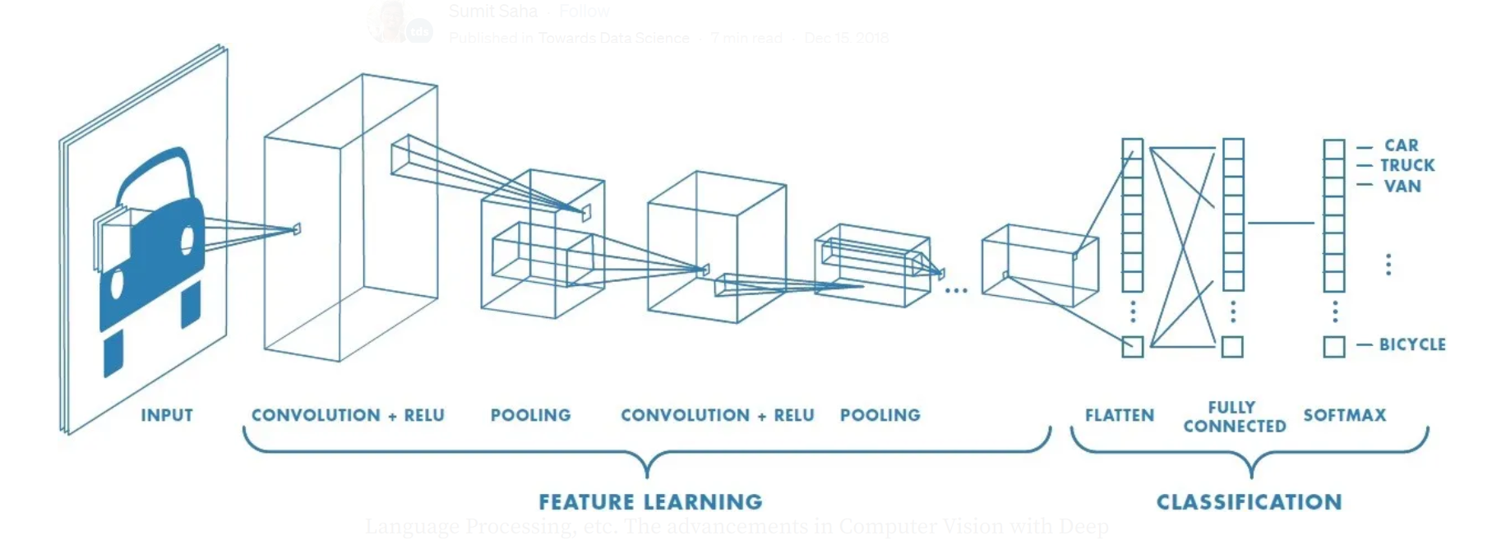
2)Flowchart illustrating the data preprocessing steps

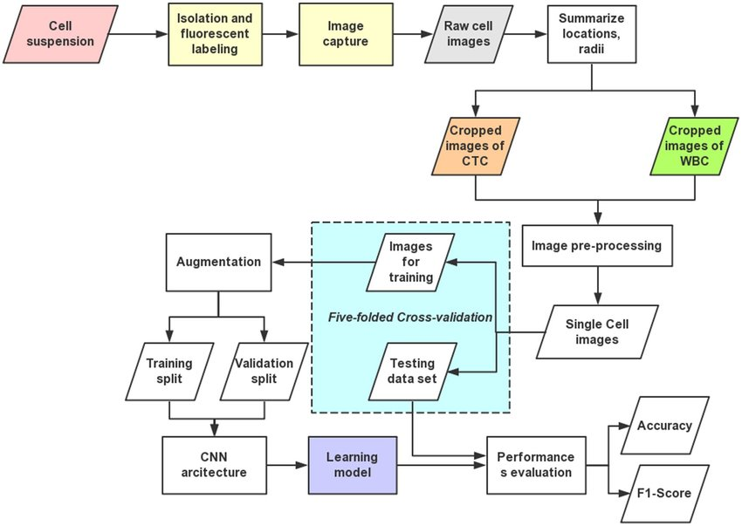
3)Example images from the dataset
FINANCE


School of Computer Engineering, KIIT, BBSR 23
SERVICE AND IMAGE CLASSIFICATION MODEL USING DEEP LEARNING

SPORTS


4)Histogram or bar chart showing the distribution of different classes in the data set
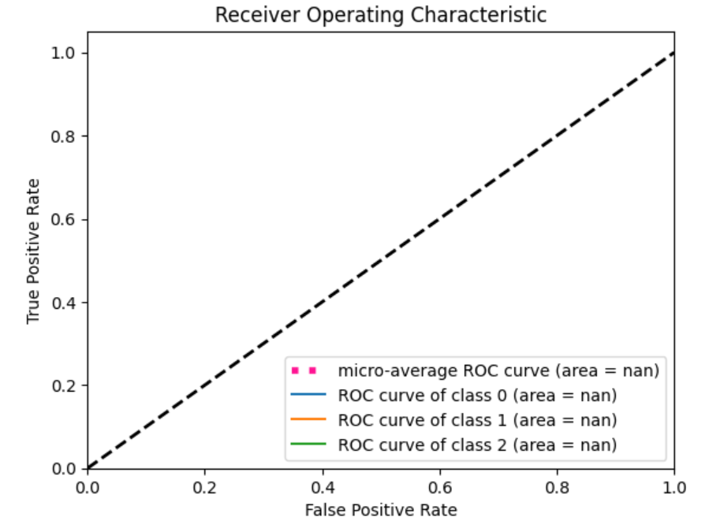

School of Computer Engineering, KIIT, BBSR 24
SERVICE AND IMAGE CLASSIFICATION MODEL USING DEEP LEARNING

5)Confusion Matrix depicting model performance on test data

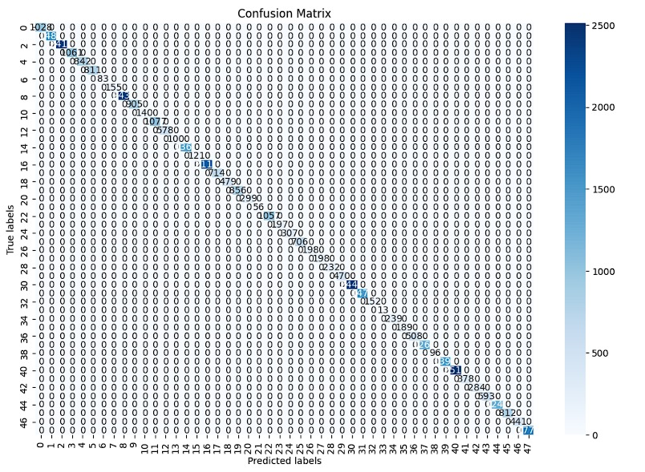

6)Learning curve showing model performance over epochs

Epoch 1/25
2/2 ━━━━━━━━━━━━━━━━━━━━ 3s 371ms/step - accuracy: 0.5625 - loss: 0.9264 - val_accuracy: 0.5526 - val_loss: 6.3274
Epoch 2/25
2/2 ━━━━━━━━━━━━━━━━━━━━ 0s 231ms/step - accuracy: 0.4062 - loss: 4.7653 - val_accuracy: 0.5000 - val_loss: 1.1957
Epoch 3/25
2/2 ━━━━━━━━━━━━━━━━━━━━ 0s 227ms/step - accuracy: 0.6250 - loss: 1.0255 - val_accuracy: 0.4474 - val_loss: 1.6658
Epoch 4/25
2/2 ━━━━━━━━━━━━━━━━━━━━ 0s 220ms/step - accuracy: 0.6146 - loss: 0.8359 - val_accuracy: 0.8158 - val_loss: 0.5366
Epoch 5/25
2/2 ━━━━━━━━━━━━━━━━━━━━ 0s 217ms/step - accuracy: 0.8333 - loss: 0.4385 - val_accuracy: 0.6579 - val_loss: 0.5114
Epoch 6/25
2/2 ━━━━━━━━━━━━━━━━━━━━ 0s 225ms/step - accuracy: 0.6771 - loss: 0.5256 - val_accuracy: 0.8684 - val_loss: 0.4287
Epoch 7/25
2/2 ━━━━━━━━━━━━━━━━━━━━ 0s 236ms/step - accuracy: 0.8750 - loss: 0.3830 - val_accuracy: 0.7632 - val_loss: 0.6530
Epoch 8/25
2/2 ━━━━━━━━━━━━━━━━━━━━ 0s 220ms/step - accuracy: 0.8750 - loss: 0.3275 - val_accuracy: 0.8421 - val_loss: 0.4232
Epoch 9/25
2/2 ━━━━━━━━━━━━━━━━━━━━ 0s 221ms/step - accuracy: 0.9583 - loss: 0.2686 - val_accuracy: 0.8421 - val_loss: 0.3265
Epoch 10/25
2/2 ━━━━━━━━━━━━━━━━━━━━ 0s 215ms/step - accuracy: 0.8958 - loss: 0.2355 - val_accuracy: 0.8684 - val_loss: 0.2967
Epoch 11/25
2/2 ━━━━━━━━━━━━━━━━━━━━ 0s 227ms/step - accuracy: 0.9688 - loss: 0.1965 - val_accuracy: 0.8947 - val_loss: 0.2655
Epoch 12/25
2/2 ━━━━━━━━━━━━━━━━━━━━ 0s 217ms/step - accuracy: 0.9792 - loss: 0.1442 - val_accuracy: 0.8684 - val_loss: 0.2270
Epoch 13/25
2/2 ━━━━━━━━━━━━━━━━━━━━ 0s 219ms/step - accuracy: 0.9792 - loss: 0.0989 - val_accuracy: 0.8684 - val_loss: 0.2874

School of Computer Engineering, KIIT, BBSR 25
SERVICE AND IMAGE CLASSIFICATION MODEL USING DEEP LEARNING

Epoch 14/25
2/2 ━━━━━━━━━━━━━━━━━━━━ 0s 218ms/step - accuracy: 1.0000 - loss: 0.0954 - val_accuracy: 0.9474 - val_loss: 0.3844
Epoch 15/25
2/2 ━━━━━━━━━━━━━━━━━━━━ 0s 218ms/step - accuracy: 1.0000 - loss: 0.0522 - val_accuracy: 0.9211 - val_loss: 0.1541
Epoch 16/25
2/2 ━━━━━━━━━━━━━━━━━━━━ 0s 239ms/step - accuracy: 1.0000 - loss: 0.0361 - val_accuracy: 0.9211 - val_loss: 0.1455
Epoch 17/25
2/2 ━━━━━━━━━━━━━━━━━━━━ 0s 213ms/step - accuracy: 1.0000 - loss: 0.0285 - val_accuracy: 0.9211 - val_loss: 0.2272
Epoch 18/25
2/2 ━━━━━━━━━━━━━━━━━━━━ 0s 218ms/step - accuracy: 1.0000 - loss: 0.0215 - val_accuracy: 0.9211 - val_loss: 0.2750
Epoch 19/25
2/2 ━━━━━━━━━━━━━━━━━━━━ 0s 223ms/step - accuracy: 1.0000 - loss: 0.0243 - val_accuracy: 0.9211 - val_loss: 0.2196
Epoch 20/25
2/2 ━━━━━━━━━━━━━━━━━━━━ 0s 215ms/step - accuracy: 1.0000 - loss: 0.0103 - val_accuracy: 0.9211 - val_loss: 0.2113
Epoch 21/25
2/2 ━━━━━━━━━━━━━━━━━━━━ 0s 242ms/step - accuracy: 1.0000 - loss: 0.0083 - val_accuracy: 0.9211 - val_loss: 0.5745
Epoch 22/25
2/2 ━━━━━━━━━━━━━━━━━━━━ 0s 217ms/step - accuracy: 1.0000 - loss: 0.0056 - val_accuracy: 0.9211 - val_loss: 0.4147
Epoch 23/25
2/2 ━━━━━━━━━━━━━━━━━━━━ 0s 218ms/step - accuracy: 1.0000 - loss: 0.0048 - val_accuracy: 0.9211 - val_loss: 0.2074
Epoch 24/25
2/2 ━━━━━━━━━━━━━━━━━━━━ 0s 238ms/step - accuracy: 1.0000 - loss: 0.0055 - val_accuracy: 0.9211 - val_loss: 0.2560
Epoch 25/25
2/2 ━━━━━━━━━━━━━━━━━━━━ 0s 218ms/step - accuracy: 1.0000 - loss: 0.0049 - val_accuracy: 0.9211 - val_loss: 0.2197

School of Computer Engineering, KIIT, BBSR 26
SERVICE AND IMAGE CLASSIFICATION MODEL USING DEEP LEARNING

References

1)Deep Learning Textbooks:
"Deep Learning" by Ian Goodfellow, Yoshua Bengio, and Aaron Courville.
"Hands-On Machine Learning with Scikit-Learn, Keras, and TensorFlow" by Aurélien Géron.
"Deep Learning for Computer Vision" by Rajalingappaa Shanmugamani.

2)Research Papers:
"ImageNet Classification with Deep Convolutional Neural Networks" by Alex Krizhevsky, Ilya Sutskever, and Geoffrey Hinton.
"Very Deep Convolutional Networks for Large-Scale Image Recognition" by Karen Simonyan and Andrew Zisserman.
"Inception-v4, Inception-ResNet and the Impact of Residual Connections on Learning" by Christian Szegedy et al.

3)Online Courses and Tutorials:
Deep Learning Specialization on Coursera by Andrew Ng.
Fast.ai's Practical Deep Learning for Coders course.
TensorFlow and Keras official documentation and tutorials.

4)Journal Articles:
Search for relevant articles in journals like IEEE Transactions on Pattern Analysis and Machine Intelligence (PAMI), Journal of Machine Learning Research (JMLR), and Pattern Recognition.

5)Conference Proceedings:
Look for papers presented at conferences such as the Conference on Computer Vision and Pattern Recognition (CVPR), International Conference on Machine Learning (ICML), and European Conference on Computer Vision (ECCV).

6)GitHub Repositories:
Explore open-source projects on GitHub related to image classification and deep learning to see practical implementations and examples.

School of Computer Engineering, KIIT, BBSR 27

SERVICE AND IMAGE CLASSIFICATION MODEL USING DEEP LEARNING

INDIVIDUAL CONTRIBUTION REPORT:

SERVICE AND IMAGE CLASSIFICATION MODEL USING
DEEP LEARNING

SAUNAK SAHA 2105660
SWAPNANIL BERA 21052962
KUSHAL BERA 21052072
AYAN KUMAR PAUL 21052064
SHUBHADEEP MOHANTA 21051937

Abstract: The aim of the project is to develop a deep learning-based system for service and image classification. The objective is to accurately categorize service-related images into predefined classes using advanced machine learning techniques, enhancing automation and efficiency in service-oriented industries.

Individual contribution and findings:-

Saunak Saha
Role: Model Development
Contribution: Led the development of the deep learning model architecture for service and image classification. Conducted extensive literature review to select appropriate CNN architectures and implemented custom preprocessing and post-processing layers. Fine-tuned hyperparameters and optimized model performance through iterative experimentation.
Planning: Formulated a comprehensive plan for model development, including research on state-of-the-art techniques, experimentation with different architectures, and benchmarking against baseline models. Established clear milestones and timelines for model development and evaluation.

Swapnanil Bera
Role: Training Pipeline
Contribution: Designed and implemented the training pipeline for the deep learning model. Developed scripts for data loading, model initialization, optimization using back propagation algorithms, and monitoring training progress. Conducted experiments to fine-tune training parameters and optimize convergence speed.
Planning: Created a detailed road map for training pipeline development, including the selection of training frameworks, implementation of batch processing techniques, and integration with data pre-processing pipelines. Scheduled regular checkpoints to evaluate training progress and troubleshoot issues.
Kushal Bera
Role: Data Collection and Pre-processing
Contribution: Responsible for collecting raw service image data from various sources and pre-processing it to ensure compatibility with the deep learning model. Implemented data augmentation techniques to increase data set variability. Collaborated with team members to define pre-processing pipelines and ensure data quality.
Planning: Developed a detailed plan outlining the data collection sources, acquisition methods, and pre-processing steps. Scheduled regular meetings with team members to review progress, address challenges, and adjust strategies as needed.

School of Computer Engineering, KIIT, BBSR 28

SERVICE AND IMAGE CLASSIFICATION MODEL USING DEEP LEARNING

Ayan Kr. Paul
Role: Deployment and Integration
Contribution: Oversaw the deployment and integration of the trained model into production environments. Developed APIs for model inference, implemented mechanisms for model monitoring and performance tracking, and ensured scalability and reliability in real-world deployments. Collaborated with DevOps team to automate deployment pipelines.
Planning: Formulated a deployment plan encompassing infrastructure requirements, deployment strategies, and integration with existing systems. Conducted thorough testing and validation of deployment pipelines to ensure seamless integration and minimize downtime. Scheduled regular maintenance cycles to address issues and implement updates.

Shubhadeep Mohanta
Role: Evaluation and Validation
Contribution: Led the evaluation and validation efforts to assess the performance of the trained model. Defined evaluation metrics and conducted experiments to measure accuracy, precision, recall, and F1-score. Developed scripts for data loading, inference, and metric computation on separate validation datasets.
Planning: Devised a systematic approach for model evaluation, including the selection of appropriate validation metrics, creation of validation datasets, and establishment of baseline performance benchmarks. Scheduled regular evaluation cycles to track model performance and identify areas for improvement.

Individual contribution to project report preparation:-
Saunak Saha -> Chapter 4
Swapnanil Bera -> Chapter 3
Kushal Bera -> Chapter 5
Ayan Kr. Paul ->Chapter 2
Shubhadeep Mohanta -> Chapter 6 & Chapter 1
Individual contribution for project presentation and demonstration: -
!)Saunak Saha
I will be responsible for demonstrating the deep learning architecture we have implemented in our project
2) Swapnanil Bera
I will responsible for demonstrating how the implementation of the deep learning method and processing the data and other operations in training the model has been done.
3) Kushal Bera
My contribution in the project presentation is to demonstrate how I have collected the raw service images from various sources which will be helpful in training our model.
4) Ayan Kr. Paul
My contribution in the project presentation is to demonstrate how the model is performing according to the data.
5) Shubhadeep Mohanta
My contribution in the project presentation is to verify if there are any errors in the model that we have created and if the model is accurate or not.

School of Computer Engineering, KIIT, BBSR 29

SERVICE AND IMAGE CLASSIFICATION MODEL USING DEEP LEARNING

Full Signatures :-

Saunak Saha  Ayan Paul 

Swapnanil Bera  Shubhadeep Mohanta 

Kushal Bera 

School of Computer Engineering, KIIT, BBSR 30

